Project Development Phase
Model Performance Test

Date | 01 September 2026
Team ID | Individual Project
Project Name | Software Installation Request Automation in ServiceNow
Maximum Marks | 10 Marks

Model Performance Testing:
Project team shall fill the following information in model performance testing template.
S.No. | Parameter | Values | Screenshot
1. | Model Summary | ServiceNow Service Catalog automation for software installation requests, covering request intake, approvals, fulfillment tasks, notifications, SLA tracking and license-related issue handling. | 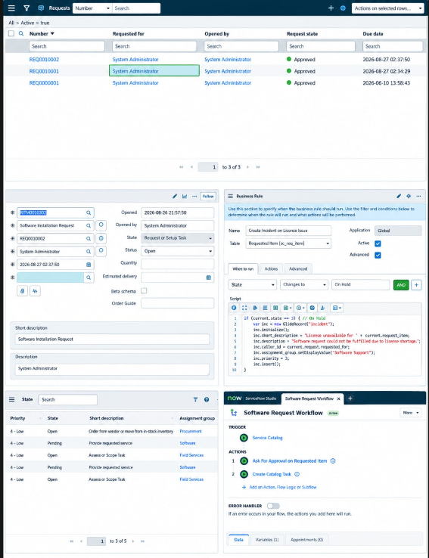
2. | Functional Validation | Verify that the catalog item, variables, request/requested-item records, catalog task, workflow/flow and Business Rule behave as configured. | 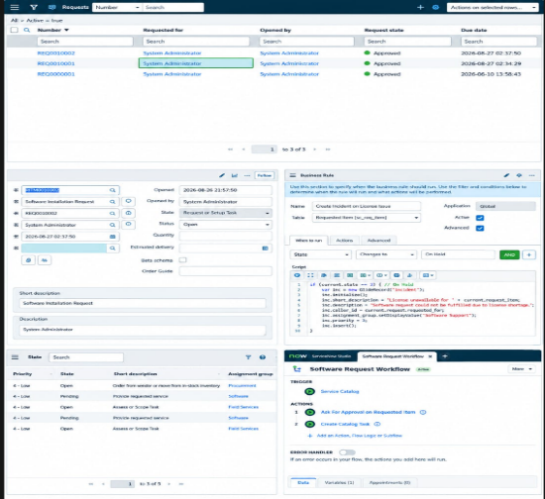
3. | Automation Result | Expected automation creates the request lifecycle records, routes fulfillment work, and creates an incident when a license shortage places the requested item On Hold. | 